SRS-DLD

S/W Detailed Level Design

Project Name | Currency Exchange System — Release 4
Block Name | Compile Commander
Author | Magnus Jaaska | Approver
Team | Compile Commander

This document represents Detailed Level Design (DLD). It describes the detailed system design and implementation plan in alignment with Agile principles. The DLD is updated incrementally with each release to reflect system evolution.

Contents

1. Overview 4
2. System Overview / Architectural Context 5
3. UML Class Diagram (Technical Design) 6
4. Class Specifications 7
5. Interfaces and Abstractions 8
6. Function Responsibilities 8
7. Operation Flow 10
8. Enumerations & Constants 11
9. Validation Rules & Future Work 12
10. Traceability Matrix 12
11. Code Structure and File Mapping 13
12. Revision History 14
Release 3 15
13. Validation Rules & Preconditions/Postconditions 15
14. Behavioral Models 17
15. Error & Exception Handling Policy 18
16. Revision History 20

- Revision History
Version | Date | Revised contents | Author | Approver
2.0 | 28.10.2025 | Initial Release 2 DLD; three-layer refactor; interfaces; method responsibilities; traceability. | Magnus Jaaska
4.0 | 19.12.2025 | Initial Release 4 DLD; file persistence; loadAll/saveAll methods; file format specification; validation rules | Magnus Jaaska
- Terms and Abbreviations
Term | Description
UI | User Interface (ConsoleUI)
DLD | Detailed Level Design document
SRS | Software Requirements Specification
DIP | Dependency Inversion Principle
SRP | Single Responsibility Principle
I/O | Input/Output (file operations)

- References
- SW Requirements Specification (docs/release-1/SRS.pdf)
- Lecture 5–7 (Design for Quality, Modularity, Abstraction, Polymorphism)
- Example DLD Currency Exchange (reference structure)
- Student Guide DLD R4 (release4_guide/Student_Guide_DLD_R4.pdf)

Overview
The Currency Exchange System automates currency conversion, verifies reserves before payout, records transactions in memory, and provides a daily summary. Release 4 extends the system with persistent file storage. This DLD defines the Release 4 design: file I/O methods (loadAll, saveAll), file format specification, parsing/validation logic, lifecycle management (startup/shutdown), and integration with the existing three-layer architecture (UI → Logic → Data). The system now supports complete data persistence across program executions.

System Overview / Architectural Context
Release 4 maintains the three-layer architecture established in Releases 2 and 3, adding a Persistence Layer.
- UI: ConsoleUI — console interaction & formatting only.
- Logic: ExchangeManager — coordinates conversion, reserve checks, and reporting.
- Data: ICurrencyRepository / CurrencyRepository — in-memory balances & exchange rates + file I/O.
- Persistence: data.txt - text file for permanent storage of currency balances
Principles: Separation of Concerns, SRP, DIP, encapsulation via header/source split, RAII for file handling.

Data Flow:
- Startup: File → loadAll() → Repository (in-memory)
- Runtime: UI → Logic → Repository (fast in-memory operations)
- Shutdown: Repository → `saveAll()` → File (persistent storage)

UML Class Diagram (Technical Design)
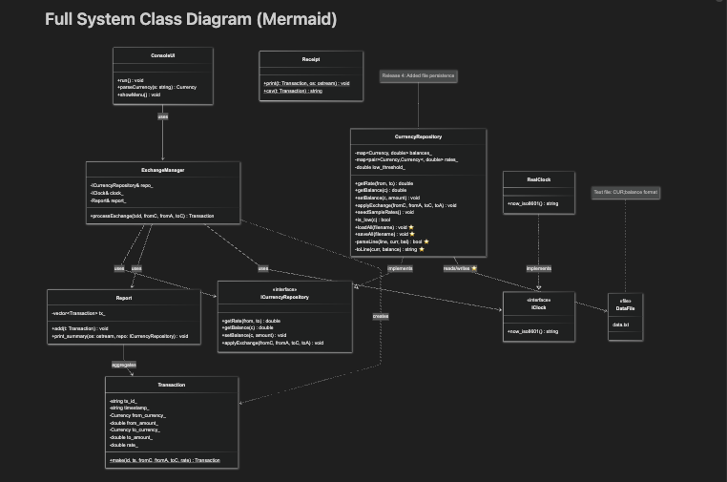
Note: All other classes (ConsoleUI, ExchangeManager, Transaction, Report, Receipt, IClock, RealClock) remain unchanged from Release 3. Indicates Release 4 additions.

Class Specifications
Class | Type | Description | Attributes | Methods
ConsoleUI | UI | Console I/O and formatting; no business logic. |  | run(), parseCurrency(s), showMenu()
ExchangeManager | Logic | Coordinates exchange; checks reserve; updates report. | repo_: ICurrencyRepository&, clock_: IClock&, report_: Report& | processExchange(txId, fromC, fromA, toC): Transaction
ICurrencyRepository | Interface | Abstracts data access for rates/balances. |  | getRate(from,to), getBalance(c), setBalance(c,amt), applyExchange(fromC,fromA,toC,toA)
CurrencyRepository | Data | In-memory balances & rates; implements interface. | balances_, rates_, low_threshold_ | getRate(), getBalance(), setBalance(), applyExchange(), is_low(c), seedSampleRates()
Transaction | Domain | Immutable exchange record w/ computed to-amount. | tx_id_, timestamp_, from_currency_, from_amount_, to_currency_, to_amount_, rate_ | static make(id,ts,fromC,fromA,toC,rate): Transaction
Report | Domain | Aggregates transactions; prints daily summary. | tx_: vector<Transaction> | add(t), print_summary(os, repo)
Receipt | Utility | Formats receipt and CSV line. |  | print(t, os), csv(t): string
IClock | Interface | Time abstraction. |  | now_iso8601(): string
RealClock | Service | System clock implementation. |  | now_iso8601(): string
CurrencyRepository | Data | In-memory balances & rates; implements file I/O | balances_, rates_, low_threshold_ | [Existing] getRate(), getBalance(), setBalance(), applyExchange(), is_low(c), seedSampleRates()  [NEW] loadAll(filename), saveAll(filename), parseLine() [private], toLine() [private]

5. Interfaces and Abstractions

Interface | Purpose | Key Methods | Planned For (Release)
ICurrencyRepository | Decouple logic from storage; enable File/DB later | getRate(), getBalance(), setBalance(), applyExchange() | R2 (implemented)
IClock | Decouple time for tests | now_iso8601() | R2 (implemented)
Release 4 Note: File I/O operations are implementation details of CurrencyRepository, not exposed through the interface. This maintains clean separation: Logic layer remains unaware of persistence mechanism.

6. Function Responsibilities

Class | Method | Purpose | Input | Output | Notes
CurrencyRepository | loadAll() | Load balances from file into memory | filename (string) | void | Skips invalid lines; never throws for malformed data
CurrencyRepository | saveAll() | Save all balances from memory to file | filename (string) | Void | Throws exception if file cannot be opened
CurrencyRepository | parseLine() | Parse one file line into Currency and balance | line (string), curr (out), bal (out) | bool | Returns true if valid, false otherwise
CurrencyRepository | toLine() | Format one balance entry into file line curr | curr (Currency), balance (double) | string | Format one balance entry into file line curr (Currency), balance (double) string Produces "CUR;balance" format
ExchangeManager | processExchange() | Computes payout, checks reserve, applies exchange, records transaction | txId, fromC, fromA, toC | Transaction | Throws on insufficient reserve/bad rate
CurrencyRepository | applyExchange() | Update balances for from/to | fromC, fromA, toC, toA |  | Encapsulated state change
Report | add() | Append to daily collection | Transaction |  | Called after success
Report | print_summary() | Emit daily totals/closing balances | ostream, ICurrencyRepository |  | Presentation kept minimal
Receipt | print() | Human-readable receipt | Transaction, ostream |  | UI use
Receipt | csv() | CSV transaction line | Transaction | string | For logging later
RealClock | now_iso8601() | Timestamp |  | string | Local ISO-8601
ConsoleUI | run() | Interactive loop; parse/execute | stdin | stdout | Uses manager; handles errors

7. Operation Flow
Startup Flow (Release 4)
- main() creates CurrencyRepository.
- main() calls repo.loadAll("data.txt").
- loadAll() opens file for reading.
- If file doesn't exist → empty repository (valid state).
- If file exists → read line by line.
- For each line: call parseLine(line, curr, balance).
- Valid line → update balances_[currency] = balance.
- Invalid line → log warning, skip.
- Report loaded count.
- If balances empty → initialize with defaults.
- Continue to UI interactive session.
Runtime Flow (Unchanged from Release 3)
- ConsoleUI reads input ("EUR 100 USD").
- Parses → ExchangeManager::processExchange().
- Manager gets rate from ICurrencyRepository, computes payout.
- Validates reserves → applies exchange in repo.
- Creates Transaction, adds to Report.
- UI prints Receipt; session continues.
Shutdown Flow (Release 4)
- User enters "quit".
- UI prints end-of-day report (Report::print_summary()).
- main() calls repo.saveAll("data.txt").
- saveAll() opens file for writing (overwrites existing).
- For each (currency, balance) in balances_:
- Call toLine(currency, balance) → formatted string.
- Write line to file.
- Close file.
- Report saved count.
- Program terminates.

8. Enumerations & Constants

Name | Value / Type | Description
enum class Currency | {EUR, USD, GBP, SEK, DKK} | Supported currencies
LOW_THRESHOLD | double = 100.0 | Alert threshold for low balances
INITIAL_BALANCES | per-currency doubles | Startup config for interactive run
DATA_FILENAME | "data.txt" | Default persistent storage file

9. Validation Rules & Future Work
Rule / Planned Feature | Description | Target
Input validation & errors | amount > 0, valid currency codes; clear error messages | R3
Strict reserve enforcement | Block payout > reserve; error codes | R3
Exception policy | try/catch at UI; noexcept in Data | R3
File I/O persistence | Save/load rates, tx, reports | R3
Unit tests | Mock IClock & repo; per-layer tests | R3
File I/O persistence | Save/load balances from data.txt | R4
File format validation | Validate currency codes, numeric balances, line format | R4
Malformed data handling | Skip invalid lines with warnings | R4

10. Traceability Matrix
Requirement (SRS) | Class / Method (DLD) | Notes
RQ-01 Convert currency | ExchangeManager::processExchange() | Core conversion via repo rate
RQ-02 Show receipt | Receipt::print(), ConsoleUI::run() | UI formatting only
RQ-03 Maintain reserves | CurrencyRepository::applyExchange() | Encapsulated data update
RQ-04 Daily report | Report::add(), Report::print_summary() | End-of-day summary
RQ-05 Time stamps | RealClock::now_iso8601() | Abstracted time
RQ-06 Persistent storage | CurrencyRepository::loadAll(), saveAll() | File-to-memory lifecycle
RQ-07 Data preservation | CurrencyRepository::parseLine(), toLine() | File format encapsulation
RQ-08 Malformed data | CurrencyRepository::parseLine() validation | Skip invalid lines, continue

11. Code Structure and File Mapping
Class / Module | Files
ConsoleUI | include/console_ui.h, src/console_ui.cpp
ExchangeManager | include/exchange_manager.h, src/exchange_manager.cpp
ICurrencyRepository | include/currency_repository.h (interface)
CurrencyRepository | include/currency_repository.h, src/currency_repository.cpp
Transaction | include/transaction.h, src/transaction.cpp
Report | include/report.h, src/report.cpp
Receipt | include/receipt.h, src/receipt.cpp
IClock / RealClock | include/iclock.h, src/iclock.cpp
Entry point | src/main.cpp
Persistent Storage | data.txt [NEW]
Build | Makefile

12. Revision History

Date | Version | Change Summary | Author
28.10.2025 | 1.0 | Initial DLD created from Release 2 refactor | Magnus Jaaska
19.12.2025 | 4.0 | Initial Release 4 DLD; file persistence; loadAll/saveAll methods; file format specification; validation rules | Magnus Jaaska

Release 3

13. Validation Rules & Preconditions/Postconditions
< Describe how your system checks input data and enforces correctness before and after operations. Each method should list clear preconditions (what must be true before it runs) and postconditions (what must be true after it completes). Indicate the layer where validation happens - UI, Logic, or Repository. Use the same class and method names as in Release 2.>
Class | Method | Preconditions | Postconditions | Validation Level (UI/Logic/Repository) | Explanation
CurrencyRepository | loadAll() | filename is valid string; Repository initialized | balances_ contains all valid entries from file; invalid lines skipped; no exceptions for malformed data | Repository | Validates file format, currency codes, balance values; defensive parsing
CurrencyRepository | saveAll() | filename is valid string; Repository initialized; balances_ may be empty | File contains all entries from balances_; previous content overwritten; throws if write fails | Repository | Critical operation; must succeed or throw exception
CurrencyRepository | ParseLine() | line is valid string; curr and balance are valid references | Returns true if valid (curr and balance set); returns false if invalid (parameters unchanged); never throws | Repository | Strict format validation; single responsibility
CurrencyRepository | toLine() | curr is valid Currency enum; balance is valid double | Returns formatted string matching file specification; always produces valid format | Repository | Assumes inputs valid (internal method); simple formatting
ConsoleUI | run() | Input fields present | Input values captured | UI | Validates all required fields are entered
ExchangeManager | processExchange() | fromA >= 0, currency codes valid | Transaction created, balances updated | Logic | Validates business rules before Repository call
CurrencyRepository | getRate | Rate pair exists | Returns rate or throws exception | Repository | Confirms data availability
CurrencyRepository | applyExchange | All validations passed | Balances updated successfully | Repository | Applies validated exchange

14. Behavioral Models
< Attach two UML diagrams that describe one key operation in your system, for example, processing an order, confirming a booking, or updating a record. Both diagrams must describe the same operation to show consistency.
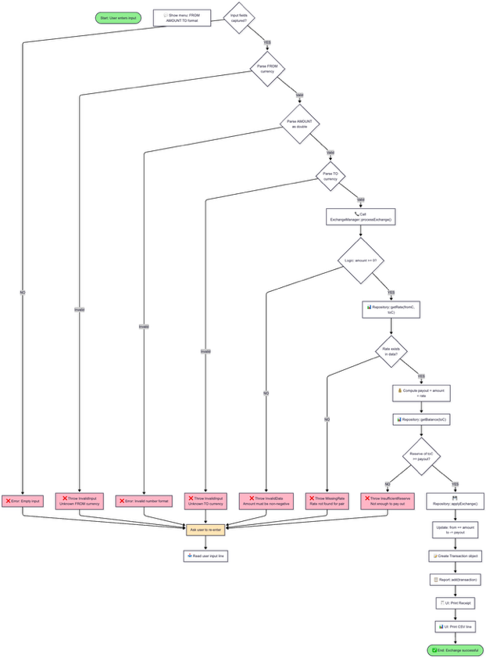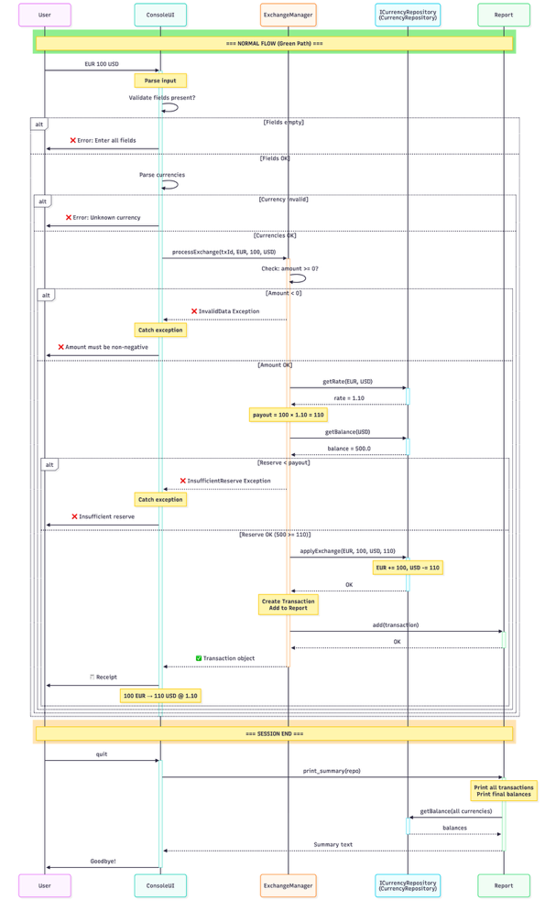

15. Error & Exception Handling Policy
< List all exceptions that may occur in your system. Describe where each one is thrown, where it is caught, what message it shows, and what the program does afterwards.
For this release, use only the three architectural layers: UI, Logic, Repository. >
Exception Type | Thrown By (Layer / Class) | Caught At (Layer) | Message / what() | Default Action (message / stop / retry)
FileReadError | Repository — CurrencyRepository::loadAll() | UI (main.cpp) | "Warning: Could not open data file {filename}. Starting with empty balances." | Show message → continue with defaults
FileWriteError | Repository — CurrencyRepository::saveAll() | UI (main.cpp) | "ERROR: Could not save data to {filename}. Data may be lost." | Show message → exit (critical failure)
N/A (skip line) | Repository — CurrencyRepository::parseLine() | Internal (loadAll) | "Warning: Skipping invalid line {lineNumber}: {content}" | Log warning → continue loading other lines
InvalidInput | UI — ConsoleUI input parsing or parseCurrency() | UI | "Please enter all required fields." | Show message → ask user to re-enter
InvalidInput | UI — ConsoleUI parseCurrency() | UI | "Unknown currency: {code}. Supported: EUR, USD, GBP, SEK, DKK" | Show message → ask user to re-enter
InvalidData | Logic — ExchangeManager::processExchange() guard clause | UI | "Amount must be non-negative." | Show message → stop operation
InsufficientReserve | Logic — ExchangeManager::processExchange() reserve check | UI | "Insufficient reserve of {currency} to pay out {amount}." | Show message → stop operation
MissingRate | Repository — CurrencyRepository::getRate() | UI | "Exchange rate not found for pair {from}/{to}." | Show message → stop operation

16. Revision History
<Track document changes across releases. >
Date | Version | Change Summary | Author
28.10.2025 | 1.0 | Initial Release 2 DLD; three-layer refactor; interfaces; method responsibilities; traceability. | Magnus Jaaska
23.11.2025 | 2.0 | Release 3 update: Added Section 13 (Validation Rules), Section 14 (Activity & Sequence Diagrams), Section 15 (Exception Policy). Documented processExchange() as core operation with complete validation, behavior, and error handling flow. | Magnus Jaaska
19.12.2025 | 3.0 | Release 4 update: File persistence (loadAll/saveAll), file format specification, Mermaid diagrams for classes and file operations | Magnus Jaaska

